Name: ___________________________________

6th Grade Music
Elements Study Guide

The Elements
Name the 7 elements discussed in class followed by the definition:

1.

2.

3.

4.

5.

6.

7.

Melody
8. Write in the Solfege syllable
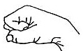 ________ 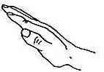________ 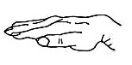________

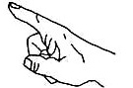______ 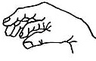 _______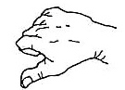______ ______

9. Putting the Solfege syllables in order makes the _________ Scale.

10. Melodies can move _________, _________, _________, _________, or _________.

Articulation
11. Match the symbol to the word and write in the correct definition

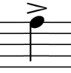
Fermata – _____ a.

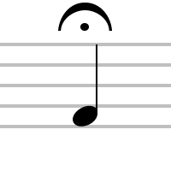
Staccato – _____ b.

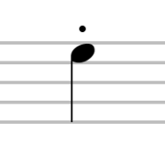
Accent – _____ c.

12. Write the symbols for the dynamics that stay the same in order from softest to loudest (the first few are given to you)

ppp pp ____ ____ ____ ____ ____ ____

13. What are the name, symbol and definition for the two dynamics that change?

Tempo
14. Define tempo

- Allegro –

- Andante –

- Adagio –

- Accelerando –

- Ritardando –

Tone Color
15. Write the four vocal ranges (lowest to highest)
Lowest Highest

________ ________ ________ ________

16. Identify at least four different ways to describe tone color (think sesame street)

Harmony
17. Match the texture with its definition and provide and draw the shape for each texture.

Shape Texture Definition
Monophonic Many voices/instruments performing different parts at the same time.

Homophonic Many voices/instruments performing different parts at different times.

Polyphonic One clear melody-many voices all singing the same part.

Rhythm
18. Draw the following notes and rests

- Whole note and rest – 4 beats
            - Eighth note and rest – ½ beat

- Half note and rest – 2 beats
            - Sixteenth note and rest – ¼ beat

- Quarter note and rest – 1 beat

Form
19. What is a phrase?

20. How many measures are typically grouped in a phrase?

21. Please explain why a song with the form AA’BA’ would be labeled as such. Explain each phrase:

A:

A’:

B:

A’:

Musical Selection
Ludwig van Beethoven
22. What is the piece we studied in depth (hint: Ms. Barnes played it on recorder)?

a. What is the bigger piece of music it is from?

23. What period of music did Beethoven write music during?

24. What happened to Beethoven while he wrote this piece of music?

