Piano Analysis Homework

Name: ____________________________________ Due Date: ___________

Period (circle): 2 or 8 ____/20 points possible

1. What is the time signature used in this piece? ____________

- In this time signature, what does the top number mean?

________________________________________________________

- In this time signature, what does the bottom number mean?

________________________________________________________

2. In the first line of music, circle the clef that is typically used for the right hand.

a. What is the name of this clef? _______________

3. In the first line of music, put a square around the clef that is typically used for the left hand.

a. What is the name of this clef? ________________

4. What is it called when these clefs are written together? ________________________

5. How many measures are in this piece? _______

6. What is the name of the first note in the right hand at measure 4? ____________

7. What is the name of the lowest note in the left hand in measure 7? ____________

8. What is the tempo at the beginning of the music? ____________

9. How many beats is the rest in measure 4? ____________

10. Using the boxed measure (measure 10), number the keys on the keyboard below in the order they would be played.
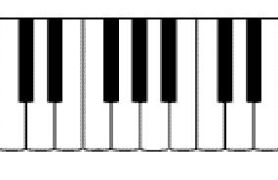

11. On your music, circle every sharp.

12. Who is the composer of this piece? __________________________

