Fingerstyle Quiz Study Guide

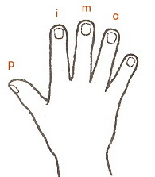

p – pulgar – Thumb
i – indice – Index Finger
m – medio – Middle Finger
a – angular – Ring Finger

Be able to fingerpick 2 out of the 3 chords in Swing Low, Sweet Chariot:

Fingerpick 4th, 3rd, 2nd, and 1st strings, in that order

Fingerpick 6th, 3rd, 2nd and 1st strings, in that order

Fingerpick 4th, 3rd, 2nd and 1st strings, in that order

