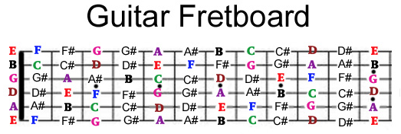

REMEMBER that as you move down the fretboard away from the tuning pegs and towards the bridge the pitch goes up half step - and the name of the note changes.

FIRST THING YOU SHOULD DO
- write down the string order on your paper! Also write down E-F and B-C

This is the order of the notes -
A - A# - B - C- C# - D - D# - E - F - F# - G - G# - (starts over) with A

