Introduction to the Piano – Worksheet

Pre-Piano Playing

My piano # is _______.

My piano partner is ___________________________________.

At each piano, I will find a box filled with the following items:

- __________________________________

- __________________________________

- __________________________________

When I am done playing the pianos everyday, I know that I will need to put EVERYTHING back into my box and will need to turn my piano OFF and push in my bench.

Play at the Piano – please check when you have completed one of the tasks below
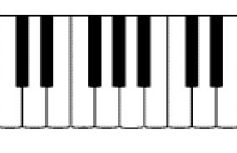
_____ C Major Chord

_____ a minor Chord

_____ 5 notes in a row with my right hand, starting on C

_____ F Major Chord

_____ G Major Chord

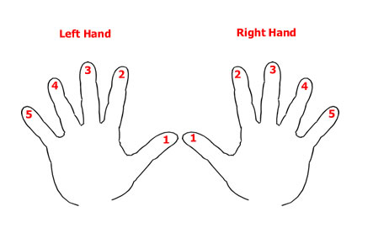
_____ 5 notes in a row with my left hand, starting on C

